CORONZR'S REPORT OF INQUEST

- ro : The Commissioner of the Yukon Territory.

Sir:

Re: Inquest into the Death of Tootsie JH ll•iY
At 4:JO P.M. on Nay 17th, 1967, I was advised by the R.C.M.P.

Detachment, Whitehorse, of the finding of a body in the Porter Creek dump near Porter Creek, Y.T. I travelled to the scene and viewed the body of a woman, fully clothed, lying on her back under some deadfall at the bacl< of the Porter Creek dump. The body had obviously been there for some time and decomposition had set in. I authorized the removal of the body, issued F'orms A and E and completed Form D. A jury met at 8:00 P.M. this date, viewed the body and the inquest was adjourned until June 1, 1967, at 7:00 P.M.
On June 1, 1967, the inquest reconvened, the jury was polled and found all present. Corporal S.A. TficLEOD, of the B.,C.M.P., advised me that some further time was needed to complete investigation int o the case and the inquest was adjour n ed again until September 12, 1967. This date was later ct.an ged to September 21, 1967, at which time the inque st proceeded.
The jury were polled and found all present and Mrs. Edna
JldHESON rep orted the inquest on authority of Mr. Justice John P.A RKZR.

The first witness was Corporal B.B. ,: cWHIRTER, R.C.r1.P., who stated that he had gone to the scene on the finding of the body on 11:ay 17th, taken photographs and measurementsa.nd he introduced -S:xh ibit #1 - a book of three photogra hs of the scene and body and copies of
this exhibit - and Exhib it ,¥2 - a n ael'ial photograph of the scene
showir13 P orter Creek dump,

'fhe second wita.ess was Lawrence Donald T.A'il'NER, a resident of Porter Creek who testified that he had gone to the dump with two other
,ersons on May 17th for some rifle practice e.n d found the body of Tootsie JI.<EY on the east side of the dump between 2:00 and J:OO o'clock in the afternoon and. that he had called the Police.
• • • 2

- 2 -

'rhe third witness was Corporal Stanley Allan McLEOD, of the R.C.M.P., and this witness also testified as to seeing the body in the Porter Creek dump on May 17, 1967, and described its condition
as that in photograpi'.1 /12 in Exhibit #L It was dressed in a green
sweater, black slacks and rubber boots. The witness introduced as Exhibit #3 a plastic bag containing several small articles such as small coins, lipsticlr and eyebrow pencil found at the scene. Exhibit
1 4 introduced by this witness was a plastic bag ccm taini ng a. letter ,
a n d envelope found near the body both of which were addressed to the d.eceased, Exhibit #5 introduced was a red and black plaid jacket found beside the body and Exhibit if 6 was a mauve sweater found under the body,

The Corporal stated the body ,'la s removed. to the Mounted Police barracks where clothing and other articles were removed. He
then escorted the body, on May 19th, to Kelowna, B.c., where an
autO!,:lSY was performed by Dr. D,F. MOE.H OW on l\lay 20th, A Viel of the deceased's blood was taken to the Crime Detection Laboratory in Vancouver for analysis. The pathologist's report, dated 31/5/67,
and entered as Exhibit #7, stated that the body v:as in an advance
state of decomposition, that there was no external sign of violence, no sign of injury and nothing unusual found in any other parts of the body, The pathologist's opinion -was that there we.s no evidence of foul -olay and the deceased probably died of alcoholic poisoning and exposure.
The witness introduced as Exhibit #8 the City Laboratory j nalysist's re})ort which sho1"ed a •36% alcoholic content in the blood and a .30% alcoholic content in the urine and no evidence of poison. I'he Crime Detection Le.boretory of the R . C. 11, P . was req_uested to ex­
amine the deceased's clothing for blood and in a letter dated June 8, 1967, and ruarlced Ex,11 bit #9, stated that stains were found on the left shoulder which was compatible ,,i ith bleeding from the nose or
mouth just before or after death and consistent with death from exposure. I'he high blood alcoholic level is compatible with uncon­ sciousness and death from alcoholic poisoning and in all probability
the alcoholic levels were higher at the time of death.

• •• J

- .3 -

J:he witness testified as to the extensive investigation carried out by the Police and stated that the last time the deceased had been positively seen was when she was released from jail on the 20th of March, 1967•. The average mean temperature from the period harch 20th to i11a y 17th was 27.77 degrees Fahrenheit and the night of IfaYch 20 - 21 it was 12 degrees belo·tJ zero and on the 24th of i'farch it v;as 26 degree3 belo;,1 zero. There was no sign of a struggle at
the scene and two broken branches indicated that the body could hsve rolled into the spot in which it was found. The witness stated 1,he deceased had a bad drinking record and on one previous occasion had been found near Mccrae on the ',!? & YR tracks in a hopelessly drunk condition, walking south and when a.ccosted stated she was
going to Whitehorse. This took place in sub-zero temperatures. The decee.sed had been discharged from the jail .iith exactly the same clothing on when she was found.
The fourth witness was Sergeant Micha.el Dwernichuk. He testified as to his xnowledge of the deceased during his tour of duty at Watson Lnke and stated tha.t she had four children and then got married in 1965, that she "\'la s interdicted, constantly drin ing and neglecting her children and generally non-manageable when under the influence of liquor. He stated that in 1965 she had walked into the Up:p er Liard ii.i ver ;,1hen drunk and had it not been for some youths
ne arby, would hc:.ve drowned on that occasion. The deceased was 26 years
of age.

The jury retired at 8:15 P.M. to deliberate and returned at 8:45 r . 1•1. with the following verdict:

"We the Jury find that one,Mrs. •rootsie J I MMY, of Up-0er Liard, in the Yukon Territory, temporarily re­ siding in and around Whitehorse, in the Yukon Territory, came to her death between the dates of March 20th to
May 17th, 1967, at or near the location known as the P9rter Creek Dump by misadventure and we the Jur·, attac. no ame a this time to any person or persons, that alcohol and exposure played a prominent pert in this individual's death.

We, the Jury, recommend that a person or persons outside of W hitehorse being sentenced to a term of imprisonment at Whitehorse be detained and not rele.s.sed until time of departure of bus, rail or air transportation to their home. rhen be esco rted onto that mode of trans-
portation ei hich they will use and not be given any type of, ,;arrent that could be turned into personal revenue."
••• 4

- 4 -

The inquest closed at 9:00 P.M.

Copies of all pertinent forms and all exl1ibit s,except Nos. J,
5 and 6 which are being returned to the deceased's parents, are attached hereto together with my account.

I ·..·;i . I I
:J

27 September 1967
- I, • j
. / ' \ VM',..,.,1j,/',-,..,.•-·,- ,· ,.."'-,..,...
for the Yukon Territory

- 4 -

The inquest closed at 9:00 P.M.

Copies of all pertinent forms and all exhibits,except Nos. 3, 5 and 6 w ich are being returned to the deceased's parents, are attached hereto together wit my account.

I/J/./J1(j .'
oo'J

iI.

2'? September 1967
. 1\ "- '
er Majesty's coroner,
for the Yukon Territory

FORM IIH"

C A J A D A ) YUKO ,·! TER,. ITORY } TO WIT: )

An inq isition t'lken for Her Majesty the Queen at the house of

1 7t hday of E.-r l
I

, ot.r-;
.)_ /').
on the
J.st
day or
.:\ 1113,

19 -€il., (and by adjourmnent on t he . /· 1. st day of C_,ei:rt,pJU ber 19 _§]_)

before -I G. T'.rnrber one or Her Majesty's coroners for the

Yukon Terr i t or y, on viGw of the body of _ _'! _o_o_t -1"5r'"·;;-_Tv_:::_, -1_'.r:._ _ _ _

_ _ _ _

then nnd there lying dend, the undersignad and _ _ _

Pet(;r Lebor;e
_ _ _ _
_ _ _ _

(i!u'.ltes of jur ymen , if 01: _, ll ca bl e )
being duly sworn and cho.rg,Jd to inquire for Her : r.ijesty when, where• how
and b•1 what means the said
* (her) deat h, do upon their oath say1 t 110.t. one lrlr s . '.1.'ootsy JT 1L Y c: U;:n e1·
Lia ....d· , Y\,1}:on To ::-:..:'._-;.,.-•·:·: ,.. t c:J .por :1"t:"D.: ' ":'1si <l.:r g_; :::· ?ri.d P.Y'•o t:3.-=... :u :.. -:ho s :;, 1W:'.:ot r .Ler ·- ­
i t ff"' .' CBJ1e - o :: 9r d 3 t' t :1 b 8: •.-.1e :--.· ·Che 1.1. ':::..t ? E c :f ::c... c ::.1. 20 ·:.,o :, _;.a y- 1 7 , - 967 at or n e l?X'
  - 1J -8 i oc o.t i cn kn c·.r£1 &.s t.1'1 '.:-or -t0. :: Cr e &·.:. ::J'i.rri,r - b- J frd . s ac1.ve n: :u.r e , a.nd .,., e at t a ch no
bl a e at t hi s t}ne tc a.'1y 9e-rscL or h: e ·cso -:1s , t h (=i.t aJ.cohcl ar d. e .. osure :;ilayed .9
prcminent part ::.r. tf.'is ini iv:.c1 .ual t s c!.ee:t.b ••

In witnoss wher eof , the coroner has i--,er e unt o set his hand (and, the
-----

jurymen have her eunt o set their han:is) this ?.le· ;

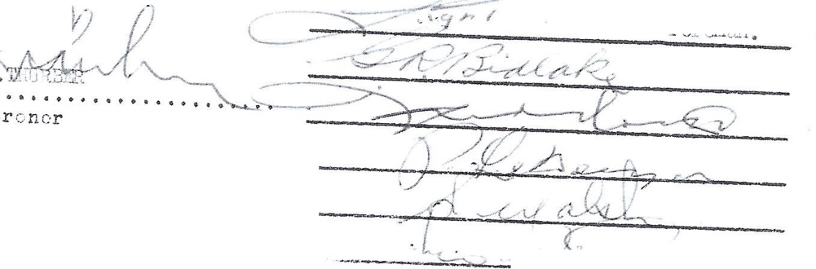
19 67/
day- of 2ep t etuY :) r

Coroner

-. . ( v

FORM "H" -

C A J A D A ) YUKO,! TER.i.ITCRY ) TO WIT: )

An inq?isition tllken for Her Majesty the Queen at the house of
in the (' H y 0f ' J',-it.ehn-..'1e on the

17th day of :M,w, ·19_67
on the- 1.,..s."t' day of J·a.ne,

196'.l-., (and by adjournment on the zi st 196'.L)
be.t'ore U. G• Thurber one of Her Mujest:r's coroners for the
Yukon Territory, on view of the body or_ T wn t ,:q J ;Di M Y.. _

then and there lying dend, the undersigned and _ _ _
_ _ _ _
_ _ _ _

J ara.e s LI GH'.r

Pe ter Lebarge
Leo 1M VUGT
being duly sworn and charged to inquire r.or Her ,,!Qjesty when, where, hov
and bv whut means the said
:iiis (her) death, do upon their oath say: that one llfrs. Tootsy JlNM'I of Upper
Lia.'!'di Yukon Te:r-r:i.tr,ry t e.mpor1:t 'd l y residing m and arounc,I Hd t0 h or se , Yukon Ter.,..­
i tor y came to tcer dea t h bet;;eqn the dates of M ir c h 20 t o ./fay 1'7,· 967 at or near the location known as the Porter Cre ek Duro. by lhi aadven tur e, and we attach no blame at this tirn.e to my person or persons, that o.lcohol and e:i:posure played a p!'oro.inerrt part in this individual I s deat h••

In witness whereor, the coroner bas hereunto set his hand ( nnd₁ the
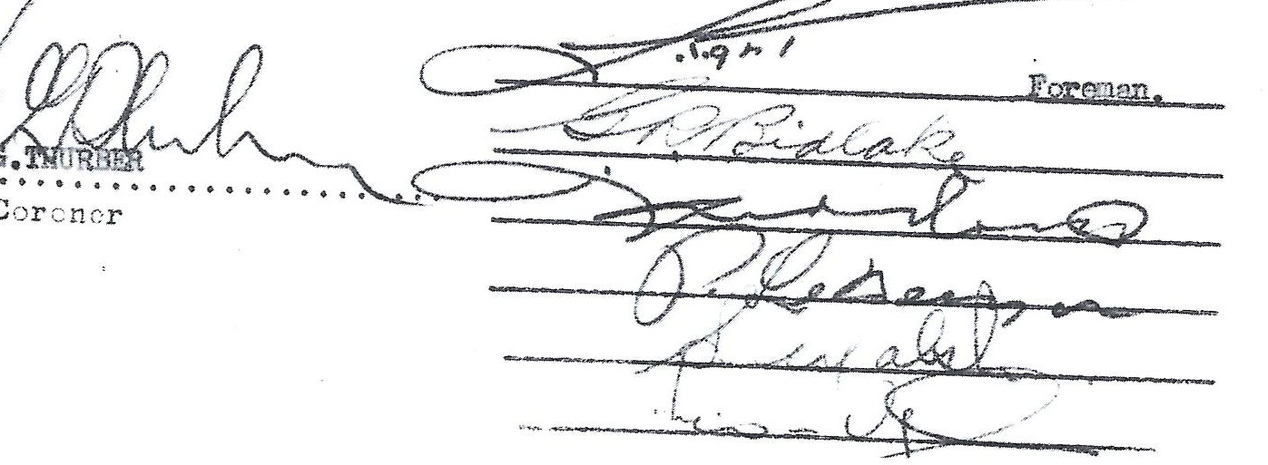
jurymen hnve hereunto set their hands) this 21st, day or Septanbe1•

FORMS UNDER CORONERS ORDINANCE SCHEDULE FORM A
WARRANT TO TAKE POJSESSION OF BODY

CANADA )
)
YUKON TERBITORY)
)
TO WI T; )

To •...,:l i.-.•. . .•/ .tif g;_

,. .f.1.\ir.7 •• and to

all constables, sheriffs or other peace officers whom it may concern:

• • • • • • • • • •'lla 0t s,y

Whereas it has been made to appear to me that
J.Jr.;J:f'.{ •••, •.•. ,• . • • • • • • • • • • • • • • • has died

. • , • , • n o- , ,r ,;, -of,:
vi .:iJ.ea o o •.• • •

(Note: here insert either:
- as a result of violence; or
- by misadventure or by unfair means or from a cause other than sickness or disease; or
- as a result of negligence or misconduct or malpractice on the part of others; or
- under such circumstances as require an investigation)

and that such body is now lying at •.,; , td,,t .: bPr :>.G• • . • . • . • • .
a place in which I have jurisdiction as coroner,

Therefore, by virtue of my office, I command you, in the name of Her Majesty, to take possession of the body of the deceased and to safely keep the same and to deal with the 1a1ame as may be directed by me until a further order is made by me concerning the same.

And for so doing, this shall be your full and sufficient warrant and authority,
Given under my hand at ,,• J-, G09f P.•......
in the Yukon Territory, this ■, l:/ t,.!. ... day of •••• :;.\l". • . . . . . .
19 •.,67 •....

! 1 /
_ 1 rt / ..
// / / : . t ., , ,)
\ ·1 1 l:i {
v'\/ \\!' . lir5cr--- · - -----------
A Coroner for the Yukon Territory

FORM "E"

WARRAlW TO SUMMON J"URY

C A N A D A YUKON TERRITORY TO WIT:

TO: Name
ADDRESS: ...... ...

By virtue of my office, I he reby direct you, in the name of Her Majesty the Queen, to summon and warn personally six persons, liable f or jury duty in accordance with the J"ury Ordinance and the Coroners Ordinance, to appear before me on the date and at the time and place indicated hereunder to undertake the dutios of jurymen on a coroner's jury to do and execute such things as shall be then given them.
You are further directed to appear at the time \
and place given hereunde r to make a return of those you shall swnmon.
Purpose of Inquest TO enquire into the death of

Particulars of Inquest

Date: :;.;; ::r_
Time: '• - ':>'-
; ', 11)' ' 7

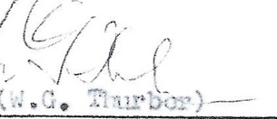
Pl a c e : : .2.t•) : ' , - .. .i.. .

A Coroner for the Yukon Territo:

FORM D

AFFIDAVIT BEFORE HOLDING INQUEST

CANADA )
)
YUKON TERRITORY )
)
TO WIT: )

I, •• ;•l•• Q- :. '.l:. Wf\ jf\ ....... of the
.. ?. .C?f°. I/1 : 1.C:.C: :3.... in the
Yukon Territory, a coroner for the said Territory,'make oath and say;

THAT from information received by me, I am of
opinion that there is reason for believing that
•••••T•o•o.t.s•7•.•.J.H.••Zt.1·Y.••.•.....•.••••now l yi· ng d ead at
•...:\ '.1t .e_l f:3.E:. ............. did not come to his death from nat.ural causes or from mere accident or mischance, but that he came to his death from violence or unfair means of culpable or negligent conduct of others or under circum­ stances requiring investigation by a coroner's inquest.

SWORN before me at )
)
)
)

Yukon Territory,
this )

/,/ l rl ·>2 :, ,.,
-J7

J..7.
dayo
f . • • .i-.J:9.. 1. -,
19 ••6•'7 )
,.,/,

...,

4 ••••,,

/ - .;-,;a,- ,..., ) )
:J .
/ ,-/, /
'-'(S• • 'Fic Leod ) Cp l. )
R .c .L. P.'.)_[ 1.c e

, / , ₋
( '·Jr_o-n..er_.., . :::-::,..

Co

FORM D
AFFIDAVIT BEFORE HOWING INQUEST

CANADA
YUKON TERRITORY TO WIT:

)
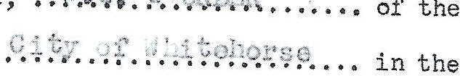
)
)
)
) Yukon Territory, a coroner for the said Territory, make oath and say;

THAT from information received by me, I am of
opinion that there is reason for believing that
, ,•••'.i•-'o••:;•t,•::;",·,,.i •i •:•:•J•.••••••.•..,••. now l y·ing d ead at
.... ,'.;: ,< Y!C: 1.e. . . . . . , . , ..... did not come to his death from natural causes or from mere accident or mischance,
but that he came to his death from violence or unfair means of culpable or negligent conduct of others or under circum- stances requiring investigation by a coroner's inquest.
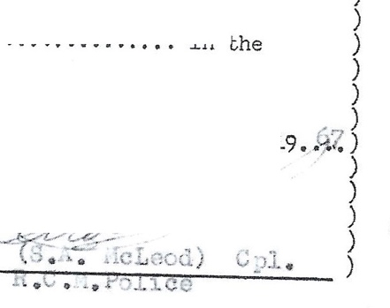
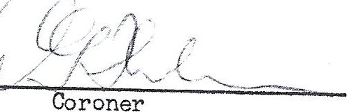
SWORN before me at
Yukon Territory, this
.+ . day of •••; ;
.., t
.. I!'. ..

'.$ : t.Jt:·.
:t11 <r-i:n \ 1 rri. l.)zrf
rio i.t :

.} (1.rr -: t3 l b·1 v ,.,;
·. r •: · t..l ·r:0 tod/ r1· '.1.uo-;:,t:;y J'!".,. l : i.1:v -1
.1/l ·1 ·; ,l (' ...,d
at.

. '·i+,1!l ,.,,. , e ir

;.:i r-c t.:' n:.- "' I!G,.s
,L,• Y·! :{en '/ •.n · ·i.., -:r.ry
o:'."" t.r ;i<.l ;,h ;
" ril l ,;. :. · i ; · t 1 .ir ·).
,i •1.t o 'Lh,

+' .· t ,he :o,.•.y !1c. ··

1."L t r ,:•'l" '. •.: 1 · t to •'ff;,"' ,i t y 1.ri t, J,•1 1 l y l: -.-rn ly
i.t. ··J"'·· ·i,·? 1'cot.. ,.::y i.Jl. • ! t o ·;, , ,. i ur·it.' ..i ; r-i..1. i·o x .. ()

t f? :: l l :.' .:"lt ll. _{[1ft} EU.f' i c i t l1J ,!. : ... .....i r t r1' " l lt,: .r.v.r 5. vy .

t'Ji n,., l; n ,:,0--:r- ,. y ii; 1 .:.

": 1...
J , t hi .-; • • ••••

( r ,. c•i .... j , . • .v . 1 9 f 7. /
/
/)
,
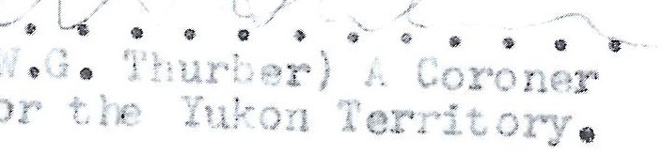
'-- - ; . , /

DEPARTMENT OF NORTHERN AFFAIRS AND NATIONAL RESOURCES

NORTHERN ADMINISTRATION BRANCH

-'

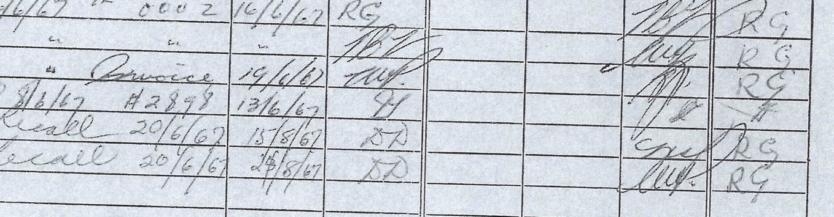
£) 's
d
f=

IR
(/)
1-3

FILE No.

613-19-2-1
Vol. 1 •
0
HO
,Z:ci
  - C/.l

o'<
1---3

.C.t..
t-,.
SUBJECT:
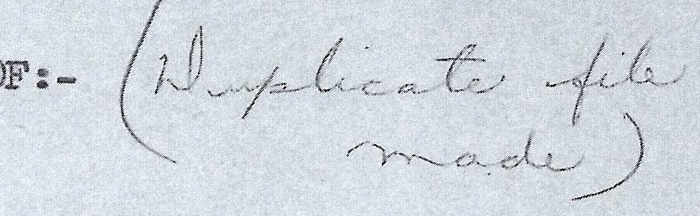
JIMMY Tootsy

INQUES'l' INTO THE DEA.TH

C!
►1---3
p:lO
1--

'°
°"
.--i
I
Ou
'aj I
., I-
',,(
I
I\ I I-

:IE
c::,
ff
INITIALS
I

:i'OR INSTRUCTIONS RE USE OF FILE COVER SEE BACK COVER

REFERENCE DISPOSAL

REFERRED TO

/.} I
--'fl
$1
L--,
-rr
-/I

P.A.
REMARKS DATE INITIALS DATE
OR T.

B.F.
DATE

REGISTRY INSPECTION

613-19-? -- I

1 .. v. ,v;.: 2? · ) ,
.Ji& ?ocue, lu o .
ll., :..0, l )61.

,/,.;
1. ' (.
-- o·.111. ,,..: L
it)_.

·<: r )z· . i ,orrc

·u .L,; to F l ..

i, "' ..: ⁰.:.. c:·., · t; -:i: yo'.l.r invoica i1 the

~mount o.,: .,.::;o •.. ._,
" ."'0' J. _{l,} I, ..,,_,_
;_• •••• 1to,,<.::y .,e:r:•.)1'1.1 ri ':.Jy y:,u on
.:. u"'t:--..J J -.u!.1:f •

l :u Yet to a i .u yo - u oroaer who oraereu
ti1i.; LUtopuy ic - )Ut.,i,.v ::rn Vi..l<.:cd;io?. all'.l he ls not
exl·,;:;ctc,d back -.:..: J.i tc.iwr..,.;: until a'..out the middle of
,u -ust. J. wou_ .... 2.i·rn to assure you that immedi::i.tely u·Jor.. his r1.;;tur .• i · ..; in,,oic-. will be uromptly presented to r..i.n 1cr a.ppr.Jv•.l an<.. your c'hequ...: w-..i.11 be moiled

.Zo::-tb.with.

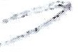
Yo tr0 truly-,

,,_, /
,.·
.,.,,

    - .. /ms
.:.I • J• r: y l :r ,
.\,rrit:;,r-i·:1.l .::ie cr et :1.ry .

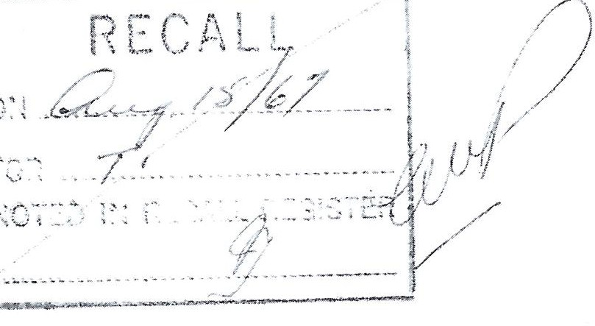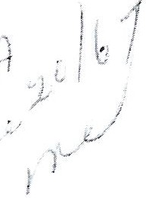

C AN A D ,r.:..

YUKON 1 Ef RI TOR I AL COURT
WHJTEHORSE, Y.T.

Box 1044,
June 16, 1967.
I
. I : - / '-/ !

he Com mi s s i oner of t· .e Yukon
1,r rr:--s 1 r1s2, { . - .
Sir: Re: lnqt:,est nto Jeatn of Tootsy ,Jil liHY The I.,.,quest into the dw3t l· of t :1:ts 1,1oman

w::-ios e body was found in ,-::,: e Porter Creek dump, hes been s t ar t e ri
and adjourned to '3e pt . IZ, 1967 to l.'lllow the RC:VTI' to c o m;::,le t e
t eir , _nve s t i ga t i on .

At t a c hed :.1er e t o is an ac coun t f r use of facilities in Ke l m.,rnci , :3. S. for the aut c psy on J,I111'1Y ' S body, t he r ema i ns had to be s hi ppe d to Kelowna as nc l ocal dee toti
coul d be f ound wl: o C'.)uld r1o the a ' it o ps y here. I D'.We cer t i f i ed the ,T . c ount prior to submission of my report, in or der that

nc umh:ie delay would be ex )er i e nc e d in payment.
I .,- ..
! ' I ·, '.1. '.• I
:,.f' ·( '• \,.,';, (_ -- -­
! , ,. .,. Thu r tB 1.•
One of .Her lY fo jest y' s corowmi for the Y uko n T e• p·it.ar )'

DEPARTMBNT OF INDIAN AFFAIRS AND NCR Tl-ISI1N DEV'l?.LOPivENT
Central Registry
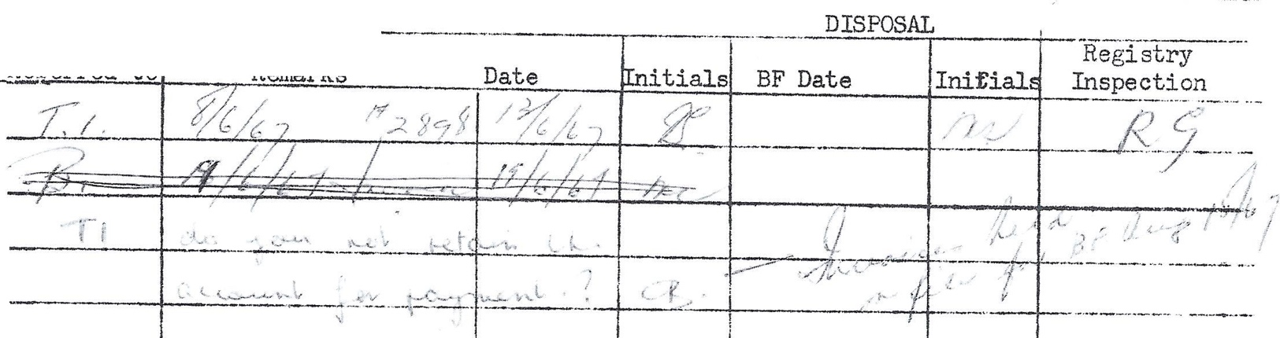
File No, ( { 3 - 1 1- - -
RE ..RENCE

- --- - ·•- ·· · - . ·····- - · -
·•··•·· ··· - - - -· ·- - - - - - - - - - ·- + | ·- ·-- - - -- | - - - -+ | - - - - - - - - - | 1 l
- - - - - -'--- - - -- ·--··----- ·•-- | -·- -·-·--.. | :-- ·• · | ---- ·---'' | -----_...

---·

-- ·

•- -- ··- ····'
. _ __ _

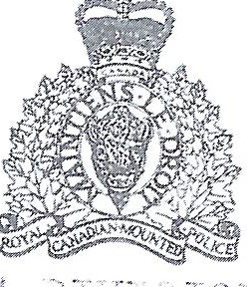

, -,!
it ) 1/.... : Jl l

YOUR No , _ _ _ _ _ _ _ _ _ _ · <
VO T R E N ° \.1•.L• ... •
) '-

OUR N o ,
N O T R E N O
.; r ; , . . f ( ) (', _ i.r:- ,·

1
...O.'i \
.-: -: . ::• , .

• • • • •• •
:! \ ?-) } ! ..O>.·.•· }·._) _(: : .t...

-' or.1r:J _ ::; 0:i o... e:- l l
' 1
• .. flt - •

or' t i1.c

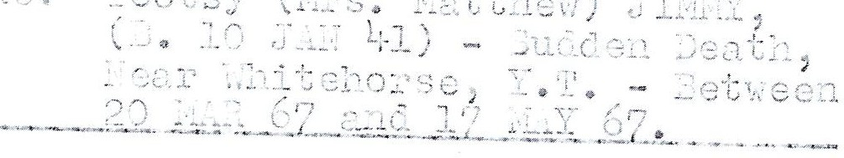

.• · :o::•j:':• ....: _ ... · :,;.--J) _'_0 5. .s t ,
. >'": • 1 0
. 1 > - .- c; ) Sc t- =i..:." '.j 1 :e-:­
:;
,::·

)/ ,.:c1 .:::, .., -; - •- ·. ,
re ct
: 7_· _1 - ;_::1r , ;_:.:1(,;:.: J.t of
:? .1;- : r J )- "' : ·· 02.l '- "'\_._:i

iJo c : o :-• -·---- · e · .s c 2 -- eC1
•

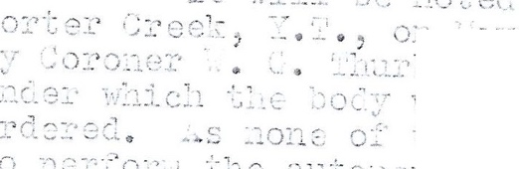
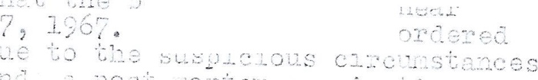
·- • ..:. I;_, _{,)} _{l} .i· ·=-.,/
')0C' ~: "' "':l ._::·. S 2- 0 C c-; l:::: :' .
..:1 - 1 l1 C' L-:.e s·t 1 • •· -
.. .1· ,: :.: 1 ) C .:•:

1. ;;;_' _ ,:
_._, .... ,-.
...., c 1.·._;1,_, ,_ , ) '="'· :·c .: ₎₀ _{.1:} · _{t} :.11 1;:: i.,-. -j ·1.-- -. L o --. -_... ,_""l_s

. , .. ;.
. : 1 ·: eiJ.o:.·s c ·• u c·: ) ;: , _: \ :-1 ·0 c:1._c .1.i .: .:e c

t o : :i c. j;: _:: o:.... _ 1 - :-1\ s :··.l: °t ,,..J. } ::: .-, ·; 1-:e ·· ) c,r.l:= · -.- 2 s t :·2. =: ) o J:· ·G : c ·Go _-. ' l O/l : T" Ct ,

:, ., (_; . , · ,_,:_- _ :- .·- J-') <;.. · t o 1 "'; r :.o : • J..10 ..r..
:. .. ,....: ...( .,::I ·?(
-;-1 .:_. _-; _" 1. ..:.. -.... ::.. :...

!1D. Ie j) o c t o,:: 0:c:r.-0 -1/ 1 -::.·e3

di r ec t 1: ·
C O!l."':.f E-::1. . t 1; .1.t l :1 )0 s Si £_,l :::,.

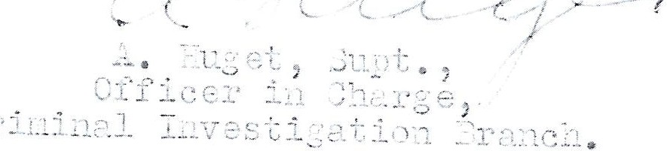

HEALTH DEPARTMENT
CITY ANALYST'S LABORATORY

J . I.., GAYTON
  - , C,P,H.

MEDICAL HEALTH OFFICER

LABORATORY

TELEPHONE: MUTUAL 4-7111
LOCAL 239

E, J. FENNELL.
M . S .A ,
CITY ANALYST 238 CORDOVA ST . EAST
VANCOUVER 4, B. C.

]''l"',r..

C9 '.. . S. _,i_, 1v:c T,ec,d.

R.. C. 1. Fn1.i c e
Y·.110 ⁰ c1b/ D-i. vi s; c,n G.I,s.

Plea06 0x8i..::::s. -1--r.e d l-:1:7 - ,, "' or:n ec f-/Lon

'!;.'"le 't,r-,:>::.! _ ; r- c
y: , T:.sc :-:--:_::i .s b a ser.r 8J. 8? 8€:

:Ji + +-'.1° e:10!·t_ ..... .:: : r.·.. +.t1 h e d ,e11 d·1 vi3 :"'i_p::--j_n:'3ti,::-: of tr cl r;fbi"\ :,-.r
1,, _{'J} _{,....,,...-;} rt: - ·i n • r r,h.;_s i _ s r, :_Y.'t 1 Ja 7_1 :- C T:-,:e +,, ::,:rr :- + f rr g!· ou9 ._{"1[;} s t,,.1 di e s
I? .t .:;5 {"'s -: ...hi ,..1,.. • 1 1i k 7.y +hat th8 1::1-:,ocl st;;:i.i.:12 f01L:-1rl 1: < ri bs
f;r0 r ,3 .. :: + ht·,.·.1; t. +. "'"'s .J._J ..\..,- r:':""'l_t-::: pr { ' A.011 f,,..,...... ±> ::-:-tb91'." rlc::•I-- ; 7_s
2 1.:: on + ...,. "' sign.: r•.; -:;,nee of' -f}1c: 1: 1.--:,0 ,1 st.:>.i'.1 c :i-:;:imi '.1::i +,.:· :-:.

Li'1 e _{rtj::.u} .::rrit:.-e· -..:; · _{"nin} r,....l ;' P. n 1.:l. oo ci
:: .c.,ir ;.,.. !,.he 1.:p :=' 2- f :-, t !''3gjr,r T:'"' s 1,-T 'Y• e; .,1-_;i.. 7· ('!'-'...., Y\.'j,, t"
"2.or: .t. rl .'.:)f' ( 1 2-;1 : h '-?' v• g,_ - :).f° th'3 eft a C sb0• l (fr:,:v-, :.'h : - ---
·,c. t • ,r, ,..y,r •"\( )'•] :i ,.... r r! 2Y,(1 -=-+.. i.s d'),"'h-:,:.. _ ·vh a ·':. "rey ca ,. "->e g: 1'1: ;>P C1 .
i_rh -.,... ,_l"t ? t··i_() ""' - ,::, r-,:,mp2.,+-:i":-=- ...; +J 1 29 --" g frn::i t he TIC·Sf: ci. d
d-:; -... ty 3)-:_")osu.,....0 Jr ot-h2..,..· f3A.nP :-rt" !.. -: +rir:-:. - .r?c r r:, c o"r!p cn"l:/t !'"'g
!}h:,si.cc,l TJi J_ nc i::. j._r . '1!'· ·!:,,, "-"1 c1+ ..r 811? ·. C .E:-nt·. +.n ":_Y"'- =r -- 1 """: C• r . r: e CTl rig
2nd :•:h e:"s ""t:e 1-,. d:-- :-- r :' erna"ined , ,, ,:-r 1i s ov·sr sd for 2r: 1r:: :.:_ r.:J. 'Tb 3v.e;
;c:,... I"' cihi-_,...: :: 1 : s 1:-· "L _ 0(1 ct e- r,r-- nr- -tr G s !_ ., 1,.:::-
l"tH P.i.Pu uli.,.. -:: --" 7.C0 1 10 J_ 0f .::s. ·i_o cp1-·_t '::
f . kt91= .):Lng 7"1 +.17 2..,..1 i.r \"" :11_;3 :_ :_2..._,c : ':"'6 .:.r:-1-,... " :" f")P '-3,. l_ '""i. "l [' rj O:: q l'""l:l1-:-
c -P- ·_10 1"'._...!: .q......(i 3J: 1J '?.,:;l1 n t 1 _y- .:?' :r 1g ')"" :::: :-\. s 1)r :t i_:: :r tr s-i
n ni r)::,1• -. 3 -rj_ +,h t. e.;. i-,r) 1;\r , _ ,.. t) ,_ e, _:=_ .:; , - .:._:- '1 - :l f; ,

JUN 111967
. .. . . .. . . 0 .. • • • 2

- 2 -

l' L P. s n t:..:G: li1'.Cns shorr.rcci p r o 10 ll C'!ed
e'(r\dertC':' of' rr_.1-·,y, 9_:t.c t :1. r.n . r l)ll! ; · .1 e _{01yr} '07 ood a1coh01 -r. :-:'.'"'0c1 _{--r•,J} 1e s 0u

_ .! nt ":""
s..., eTic -: ,,...:,
,n, J rr;f ,•-·:1 :_-- .-¹ s 0 t11 ; 't. 1 R.rt e 2.c or1 r,! ., t1: e ...,,3.
is 0 ' :.r i d n e

tbR c-: J.c0 hc . c :· r, be r o (i· i c, .:? t.0 some e. :t ;n t a.ft.er d.8at r1u:rir. g

4
the :1":
    - -r"e f P
t_ -i ri:
- : f r 0 :! 1=-s 3 J - ..,f! c: ri "1'"'t ,... r, t s ; . d er that tr.s 1 1 c 0 ho l

pr cJ,i ed -f',~rirr tbi::; s cur --:; s, W'Y l d 1::'3 of m t:-. e h <::on s e .:p ' e:i s• :; , r,,,,
P -r• -3:_:-¹ l t of · 1.t f"?i_t e _{}:--.7} ? : _{;n3:1} :.. _{P.} _{t} ...!_nr- 1)7 c-ur :::e l 'f:-s s :; f ;;; e _{+,h} _{.1:.} _{+,} it
:>"
:..:r" J'u.2.2 n 1=- v·· 1:H3 J rr.0r: · a:: . l..!.e: . · e .:::r+-,a. ..... ;011·C '>"; c;1re 'r•
, ► • 20 ').,,.. . ; o . :: 1,- 0. 011. lc"! '·-.:; '9rnr::!t-n'r e;.· .:;d . _{t.00.} -rh ,q_t when
put -ref a.ct i on i.5 s a ve e a l col-) o 7. ;_:: p; ·o .1.?1:: .r ors J.1_1 --:-el .t tC) (:3 1;st
- h a r' g s 1 ; y,2 •-i;s.. . 'rl: 1s , t 1 1n : ""i ?..1. .-,, 0 .. : _::! :1- v b er ,:n e·, n nigb.t.:!r

a the t.t·me 0 ."':
1- e ;."? 't' .

I uc; " -,- wo

2.l c i: rJ1 Gor:t 1::1'.1t , 'J!. '."'e "r'1

:.!1P.,

c.2+. Jhr Jug .1 no t i d e;Jt i c -1 . r1r.-i. ;,-. tha.t. (" th e '.J l _o c 'J! co n2 i de:ri :1 : ,4.,.,h ,3t,
- be s a"fl!)l - s were i_:1 10 0 ::. r.;0 ;. (' i _ tii o , e:rt a:Ln l . -:,r c o r ; _ -: rr s +.1 ·.:e c>4'·,
.1.'.'.·¹ :: t. t.b 3re w;:is a. l rl_rg o r:'1Q1 1 +- :-)P -? ,_ ')to2- :.. J tb f '. ,,,_;0 1 w ll P '7 0e::> 4-. i
,:,,-;r_;11 T• ,..1

.1..f vou v;: . £:h a r :,... e.. tte t r:1<de t o :..,.·0 11p
t e 1:l'Jr',( --t p; _ _: 1 ? . k f ·--,0 1 .,:... '..• 2t , ·n e 1( '1:r r.,·z1 11·: . _{c;(irl} -1- a t th C

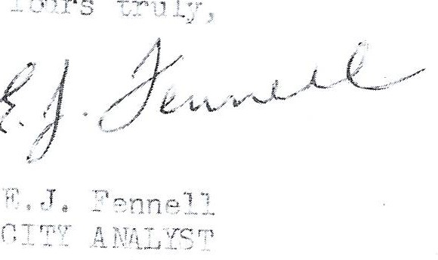
cn:· dition o:' t:'-:; b'.!.,:- r;d ">:,.. :::-1e ci€;CeP.s e d ni2l: es th e + ,s-nrr.!_ ;}a t 2o. r,

----

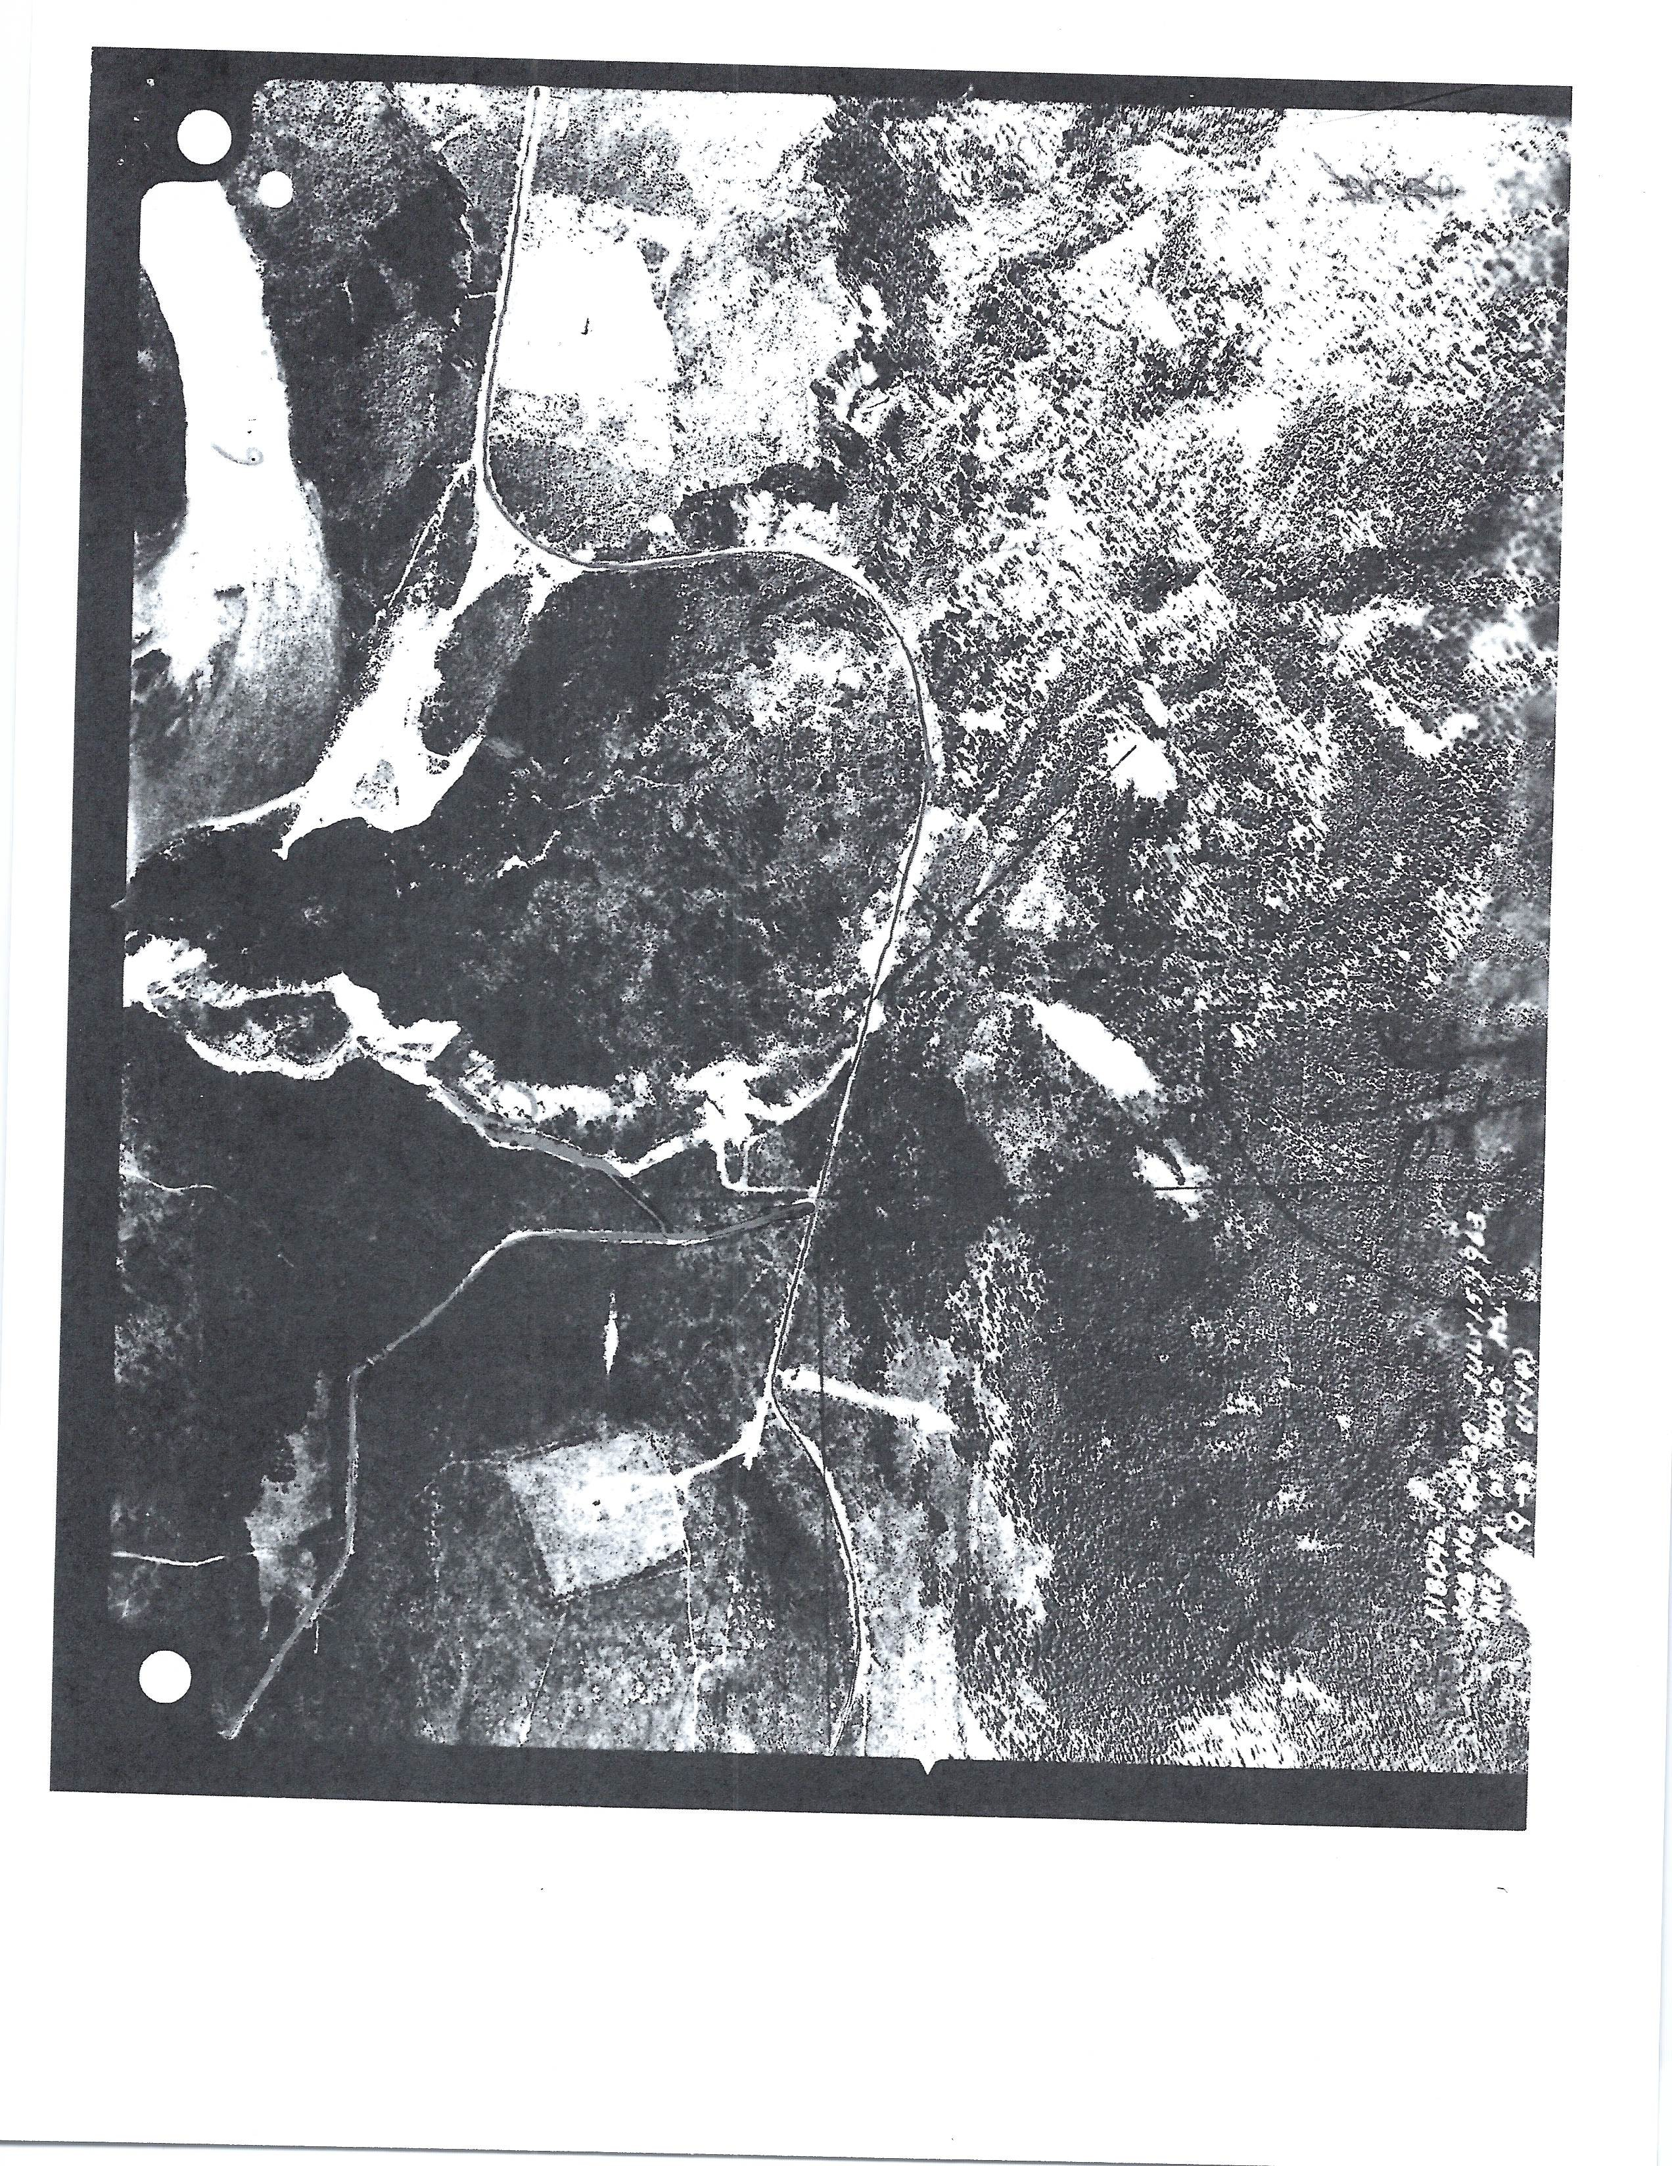

L ·root··y ,(1r-
: . Mst t eu ) JL..i•iY L1. 1 0 - 1 - 4,l } 1<-, ;651V l - u.d .:en Dec.th

-!k-,2-:r- -1-i-,t -:'
-n)! ' ';f:J , -l -o'.-' •-- -tc-t1/-e(-n -tt -I -2.i.-J •-•.-.!-l 61' -C -1 7- h-t.Y- 6-7.-

--- 1.k. ck Ii.o,.id ,.-r·ori1
2. - - - to a to : orter
ilc >1 7. 5 ::..:11D to
Cro..-!:_ J u .:ip o
, :d l e 9 2;2 ,.':uc

3. - • ao J to D . v .' l' •. L dio J.1··ui ,:1(·n t .

I, •
5.

6.
c::::::.:;)
."..'.
i' c r t ri :;• Crcet dum p. ody ,;en; t·oun c•!
Yt/·on Ei v1r .

-
CORC N E:RS li\JQUEST
, , } /
I
' ' i r:. i:• . ;''.,: : .. : ; '""'""'- //
1, 1,1, ,,, E, ,_. _, _ ·- - --- --· --·------:- - --- -- ---
I
......:-. :./ .
rnfon,::: J· .:, · ·, , · : ·. ( · _·::u,
:
.f ,..
I , tj / (
.. ·_-' :: - - --' -- - ----------- '

i-,i,,4.0: l1•,• ¢;_r•. / N1,,•,;, ; L, ,,-, .,, .• ' -· ,• _•..l I . ,'_.., ,,,._._,. .,,...1',1.

j:
0- • 1' 1

1.........
I
J:. · 1--
L c.. J. .. J- . . C..::-:. _.:=::::, _ . _
--/-.-c--c. ,:L!_ · _JL«l' .:J .
c -:;: ic-1\1 '.:R or -rrep-orter

- - ._- - --- - - --- ·- - - -.,..........,-- · ---.,f'

AUTOPSY REPORT
O K A N A G A N V AL L E Y HOSF ALS
DEPA R T ME N T OF P A T H O L O G Y KELOWNA GENERAL HOSPITAL

AUTOPSY NO·- - -c"\_6_7_-1__0_2 _

oocToR NAME
JI ;M;..:t:·;.I.;;'·Ll•- T..c.o...o::.. t s_Ly .(=..l--1r-s-•--M-'a:_t_t_ew )

HOSPITAL NO. _

DIED AUTOPSIED

Y.iay 20/67
BY D. F. Mor Dow,_

M. D.

COLOR XSE
RACIAL ORIGIN AGE 26 _

AUTOPSY PERFORMED AT _ _

_ _ _
_ _ C_la_rk_e _& _D_ixo_n _Fu_ n_er_al _Ho_m_e , _ K_elo_t·_ma_,
_B . _C.

Coroner: Nr . W. Go Thurber, Whitehorse, Yukon
Body identified by Cpl. S.A. McLeod, R.C.M.P
CIRCUt-fiTANCES OF DF TR:

Thie body of this North American Indian woman wa s found on a garbage heap about three miles from Whi t e hor s e , Yukon. It is uncertain when she was last seen alive but it is considered that she niay have been dead several weeks.
The body is that of an Indian woman measuring 5 feet 5 inches in length and weighing an estimated 120 pounds. The body is in an a dva nced state of de­ composition and it is heavily populated with maggo t s . There are no external slgns of violence.
INTERl \L EXAMINATION:

There is no evidence of injury to the sternum or ribs. There is no blood in the pleural cavities or pericardial sac. Examination of the heart and lungs shows no evidence of disease or injury. The diaphragm is intact•

.ABD011EN;

The viscera are in their normalr ela t i onnh i p. The tissues are in an advanced state of autolysis.
LIVeR: Unr emar kab l e. SPLEEN: Unremarkable. PANCRJU!..S: Unremarkable.
STOMACH & BOWEL: Unremarkable.
k\DRENALS, KIDNEYti & Bl.ADDE}.{: Unremarkable.

BRAIN:

Ther e is no br ui s i ng of the scalp and the skull is intact. There is no free blood in the cranial cavi ty. The brain ... how s advanced autolysis.

K{t'STOtlf BUSIN[SS fORlilS llO - V.lKCOUVER

AUTOPSY REPORT (Cont=-,ued) OKANAGAN VALLEY HOSPll AlS DEPARTMENT OF PATHOLOGY

AUTOPSY No. ......... A9.7.-=.HJ.Z. JIMMY, Tootsy (Mr s . Mattew)
page 2

SPEC Il 1ENS OBT! I NBD:

Portions of heart and lu ng tissue were retained for microscopic sect ions. Specime ns of blooq, urine, liver, kidney, stonia ch cont ent, hair and nails wer e pl aced in suitable containers and turned over to Cpl. McLeod for toxicological invest igation.
DFM:pn
:May 23/ 67

J\1IC :oi:;GOPI C J.EPOf'I1:

rITOCARDTu1•I: Re rp es ent at i ve s ect i ons show aut ol ys 'i..s of tissue :rit,h loss of
cellular detai l . There is _{l'lO} evidenc of an in.fJ.ammatoryr eact i on.

LU:NGS: Sections :fr m 'J:Jth lungs show an es s ent i al ly norm.al arc.itectur.e There is flt1.id with..i11 some of the alveolar spaces but t is r.nay \vell be due to post mor t em transudation. There is no evidence of an i nt r i ns i c di.sea.se proces s .

E.xa.r"!l.ina;tio.:i of the body in this case, r evealed e. rather advanced state of post mor t ei'.! decomposition whi ch na.l:<es it difficult to dra.-.- any c oncl usi ons from tissue exarrii nat io n . Estima:t.fon of the time of dea.t h :is difficult due to man • factors affecting t he rate of post mortem decompos i t i on and in
r,ra t :Lc u.l.ar , t he temperature, exposure, etc. Howev e r , I would est Lni3, .t e the
t:i.I'.le of deat h as anywhere bet we e n ten days and t hr ee we e ks . rior to the time of autor,s;r . Exte nal an, i nt ernal exami nat i on revealed no gross or micro ­ scopic evi1enc e of di sease Gr i n j llr"J. Toxi col oe;i ca l i nv e s t i g at i on has y e t
tc be carried cut, but in :i' f opinion, there is no anator:ri.cal evi d ence of foul play and alcohol plus exposure would have to be cons i der ed as pr obabl e causative r ctors.
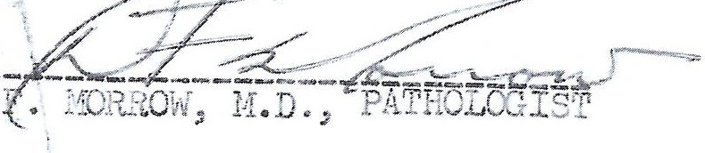
DFii:la
iV..?.y 31/ 67

H 300-MLH

TO ,,.-,

City Analyst's Laboratory
238 East Cordova Street Vancouver 4, B.C.
_ _ _J_u_n_.1_0s_'.)_';_r. 19 l 7

CERTIFICATE OF ANALYSIS
• 'J. ., •• . _{I} ♦ 't-\ :t• _

I, the Unde rsigned Analyst for the City of Vancouver, do hereby cert if y that I received on the _ _ _ _ _ _

day of ·· _'·-_
- - - - - - - - - - - - 1 9 -_;/_

fro1n- - - - - _-l c_ ·' _c _. _r_s. _{l.'_.} _·:1'._, _ : _ !.c;c-_l _O, f_1,_;_-.c_. .c_!-_-'--'-[''--_. .,,-1'._•·_; ; _{--'} "-,--;c!"...:.O't_i._-=r_e:,::.:.· ·?_:.:_'•'._' _; • l_:.P_ •c;_ rc._rc_·i.:-:=. -r'--)'---t-''·--•1b_ _ _ _ _ _ _ _ _ _ _

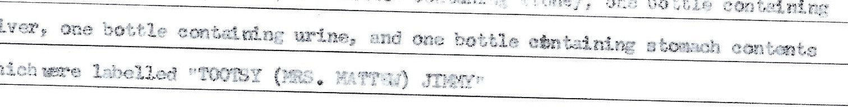

and declare the result of the Analys is to be as follows:

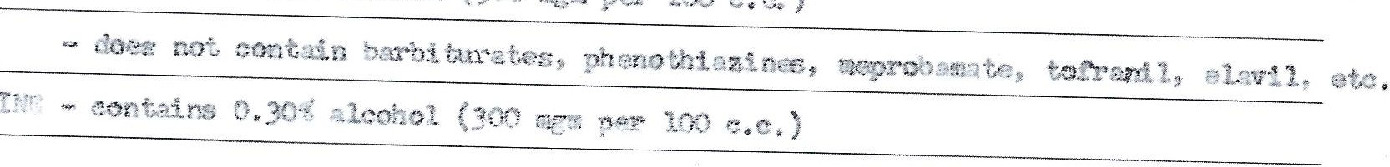

C : -- ;• ., I ,r ..•rg 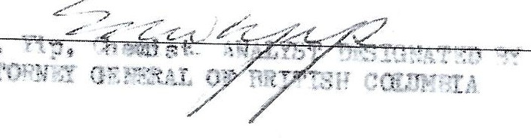
.: : , 1--1 :s:.L- ;• , ..,. •
.!;,l . ii. , .. :::-..Lro,J
f .o 8 i '!'i ·31on, G. _ . .
-r n:T- ;. ;oY-, .' Y . T;t

This
CORONCRS INQ'JE:;T
,/
T .
, ( 'j•1rtc of
. ...
.... .... .
is EXHI''

refcrr t:, , ;,
, ..
k .
r,1./
,;.,
L.
koll
.
! '
ta a, i • _j;c death cf
,1 t
--
2·

..., r
c.
o1
µ·⁻
- >.
..... ..£ (,.(.,(.t,U..J...

..L.t. . r..?,.... . >=== ····
/
f..;"-iKC,ff R o

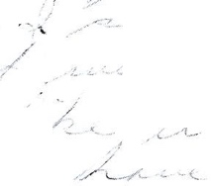
/
·-: _
/ /.

- ·1

1

7
' ,' /t

I. J. ,
,( /,'{
I
l

,:;/_..,

; 2 -

/ /

' { ,. I -
' (

/ / , / .
/ ./
/
": / /., ! .r

I 1, '

,,.. _ ,,./.. .,
I /

/ / . /
./_.

- ) _,

I

/ , _· /.

